**[1. Scala's real-world project repository data](https://app.datacamp.com/workspace/w/34c17ec9-c660-4d08-a8fe-1d99662b302d/edit" \l "1-scalas-real-world-project-repository-data)**

# Importing pandas

**import** pandas **as** pd

​

# Loading in the data

pulls_one = pd.read_csv('datasets/pulls_2011-2013.csv')

pulls_two = pd.read_csv('datasets/pulls_2014-2018.csv')

pull_files = pd.read_csv('datasets/pull_files.csv')

[**2. Preparing and cleaning the data**](https://app.datacamp.com/workspace/w/34c17ec9-c660-4d08-a8fe-1d99662b302d/edit#2-preparing-and-cleaning-the-data)

# Append pulls_one to pulls_two

pulls = pulls_two.append(pulls_one, ignore_index=**True**)

​

# Convert the date for the pulls object

pulls['date'] = pd.to_datetime(pulls['date'], utc=**True**)

[**3. Merging the DataFrames**](https://app.datacamp.com/workspace/w/34c17ec9-c660-4d08-a8fe-1d99662b302d/edit#3-merging-the-dataframes)

# Merge the two DataFrames

data = pulls.merge(pull_files, on='pid')

[**4. Is the project still actively maintained?**](https://app.datacamp.com/workspace/w/34c17ec9-c660-4d08-a8fe-1d99662b302d/edit#4-is-the-project-still-actively-maintained)

%matplotlib inline

​

# Create a column that will store the month

data['month'] = data['date'].dt.month

​

# Create a column that will store the year

data['year'] = data['date'].dt.year

​

# Group by month_year and count the pull requests

counts = data.groupby(['year', 'month'])['pid'].count()

​

# Plot the results

counts.plot(kind='bar', figsize = (12,4))

<matplotlib.axes._subplots.AxesSubplot at 0x7f55b5ec75f8>

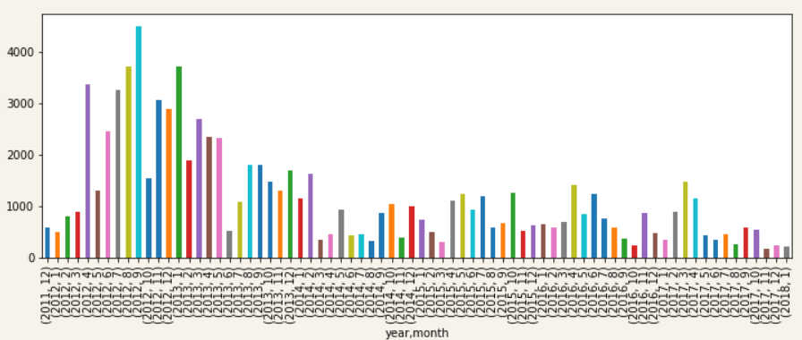

[**5. Is there camaraderie in the project?**](https://app.datacamp.com/workspace/w/34c17ec9-c660-4d08-a8fe-1d99662b302d/edit#5-is-there-camaraderie-in-the-project)

# Required for matplotlib

%matplotlib inline

​

# Group by the submitter

by_user = data.groupby('user').agg({'pid': 'count'})

​

# Plot the histogram

by_user.hist()

array([[<matplotlib.axes._subplots.AxesSubplot object at 0x7f55b651a358>]],

dtype=object)

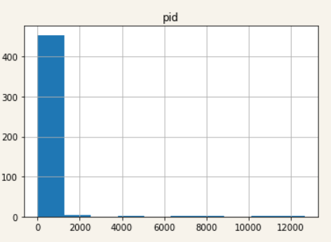

[**6. What files were changed in the last ten pull requests?**](https://app.datacamp.com/workspace/w/34c17ec9-c660-4d08-a8fe-1d99662b302d/edit#6-what-files-were-changed-in-the-last-ten-pull-requests)

# Identify the last 10 pull requests

last_10 = pulls.sort_values(by = 'date').tail(10)

last_10

​

# Join the two data sets

joined_pr = pull_files.merge(last_10, on='pid')

​

# Identify the unique files

files = **set**(joined_pr['file'])

​

# Print the results

files

[**7. Who made the most pull requests to a given file?**](https://app.datacamp.com/workspace/w/34c17ec9-c660-4d08-a8fe-1d99662b302d/edit#7-who-made-the-most-pull-requests-to-a-given-file)

# This is the file we are interested in:

file = 'src/compiler/scala/reflect/reify/phases/Calculate.scala'

​

# Identify the pull requests that changed the file

file_pr = data[data['file'] == file]

​

# Count the number of changes made by each developer

author_counts = file_pr.groupby('user').count()

​

# Print the top 3 developers

author_counts.nlargest(3, 'file')

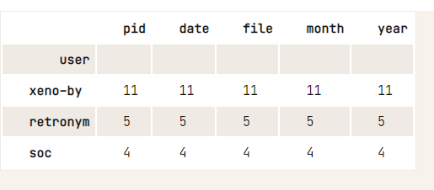

[**8. Who made the last ten pull requests on a given file?**](https://app.datacamp.com/workspace/w/34c17ec9-c660-4d08-a8fe-1d99662b302d/edit#8-who-made-the-last-ten-pull-requests-on-a-given-file)

file = 'src/compiler/scala/reflect/reify/phases/Calculate.scala'

​

# Select the pull requests that changed the target file

file_pr = pull_files[pull_files['file'] == file]

​

# Merge the obtained results with the pulls DataFrame

joined_pr = pulls.merge(file_pr, on='pid')

​

# Find the users of the last 10 most recent pull requests

users_last_10 = **set**(joined_pr.nlargest(10, 'date')['user'])

​

# Printing the results

users_last_10

{'bjornregnell', 'retronym', 'soc', 'starblood', 'xeno-by', 'zuvizudar'}

[**9. The pull requests of two special developers**](https://app.datacamp.com/workspace/w/34c17ec9-c660-4d08-a8fe-1d99662b302d/edit#9-the-pull-requests-of-two-special-developers)

%matplotlib inline

​

# The developers we are interested in

authors = ['xeno-by', 'soc']

​

# Get all the developers' pull requests

by_author = pulls[pulls['user'].isin(authors)]

​

# Count the number of pull requests submitted each year

counts = by_author.groupby([by_author['user'], by_author['date'].dt.year]).agg({'pid': 'count'}).reset_index()

​

# Convert the table to a wide format

counts_wide = counts.pivot_table(index='date', columns='user', values='pid', fill_value=0)

​

# Plot the results

counts_wide.plot(kind='bar')

<matplotlib.axes._subplots.AxesSubplot at 0x7f55d0cd2470>

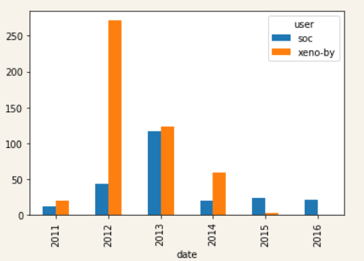

[**10. Visualizing the contributions of each developer**](https://app.datacamp.com/workspace/w/34c17ec9-c660-4d08-a8fe-1d99662b302d/edit#10-visualizing-the-contributions-of-each-developer)

authors = ['xeno-by', 'soc']

file = 'src/compiler/scala/reflect/reify/phases/Calculate.scala'

​

# Merge DataFrames and select the pull requests by the author

by_author = data[data['user'].isin(authors)]

​

# Select the pull requests that affect the file

by_file = by_author[by_author['file'] == file]

​

# Group and count the number of PRs done by each user each year

grouped = by_file.groupby(['user', by_file['date'].dt.year]).count()['pid'].reset_index()

​

# Transform the data into a wide format

by_file_wide = grouped.pivot_table(index='date', columns='user', values='pid', fill_value=0)

​

# Plot the results

by_file_wide.plot(kind='bar')

<matplotlib.axes._subplots.AxesSubplot at 0x7f55d0d1c7f0>

